Lab 4

|  |  |
| --- | --- |
| Function | Big O |
|  |  |
| int*linear_queue;  int linear_queue_size;  int*circular_queue;  int circular_queue_size;  int opCode;  int frontL=0, rearL=0;  int frontC=0, rearC=0; | O(1) [declaration]  **O(1)** |
| int isLinearQueueEmpty()  {  if(frontL==rearL)  {  return 1;  }  else return 0;  } | **O(1)** |
| int isLinearQueueFull()  {  if(rearL==linear_queue_size)  {  return 1;  }  else return 0;  } | **O(1)** |
| int linearEnqueue(int x)  {  if(rearL==linear_queue_size)  {  return -1;  }  else {  linear_queue[rearL]=x;  rearL=rearL+1;  return 1;}  } | O(1)[comparison, return]  O(1)[index, assignment]  O(1)[arithmetic, assignment]  **O(1)** |
| int linearDequeue()  {  int x;  if(frontL==rearL)  {  return -1;  }  else {  x=linear_queue[frontL];  frontL=frontL+1;  return 1;}  } | O(1)[Declaration]  O(1)[comparison, return]  O(1)[index, assignment]  O(1)[arithmetic, assignment]  **O(1)** |
| int isCircularQueueEmpty()  {  if(frontC==rearC)  {  return 1;  }  else return 0;  } | O(1)[comparison, assignment]  **O(1)** |
| int isCircularQueueFull()  {  if((frontC==0 && rearC==circular_queue_size-1) || (rearC == frontC-1))  { return 1; }  else return 0;  } | O(1)[comparison, logical operator, return]  **O(1)** |
| int circularEnqueue(int x)  {  if(isCircularQueueFull())  {  return -1;  }  else  { circular_queue[rearC]=x;  rearC=(rearC+1)%(circular_queue_size);  return 1;  }  } | O(1)[function, return]  O(1)[index, assignment]  O(1)[arithmetic, assignment]  **O(1)** |
| int circularDequeue()  {  int x;  if(isCircularQueueEmpty())  { return -1;  }  else  {  x=circular_queue[frontC];  if(frontC==rearC)  {  frontC=0;  rearC=0;  }  else{ frontC=(frontC+1)%circular_queue_size;  }  return x;  }  } | O(1)[Declaration]  O(1)[function, return]  O(1)[index, assignment]  O(1)[comparison]  O(1)[assignment]  O(1)[arithmetic, assignment]  **O(1)** |

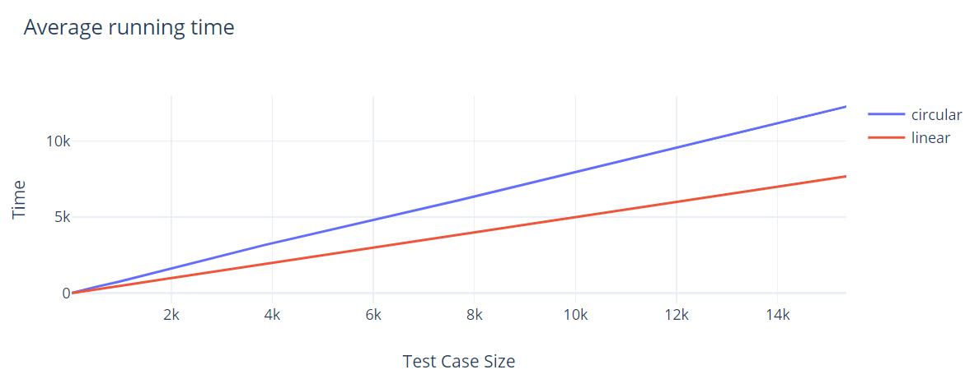

Ex

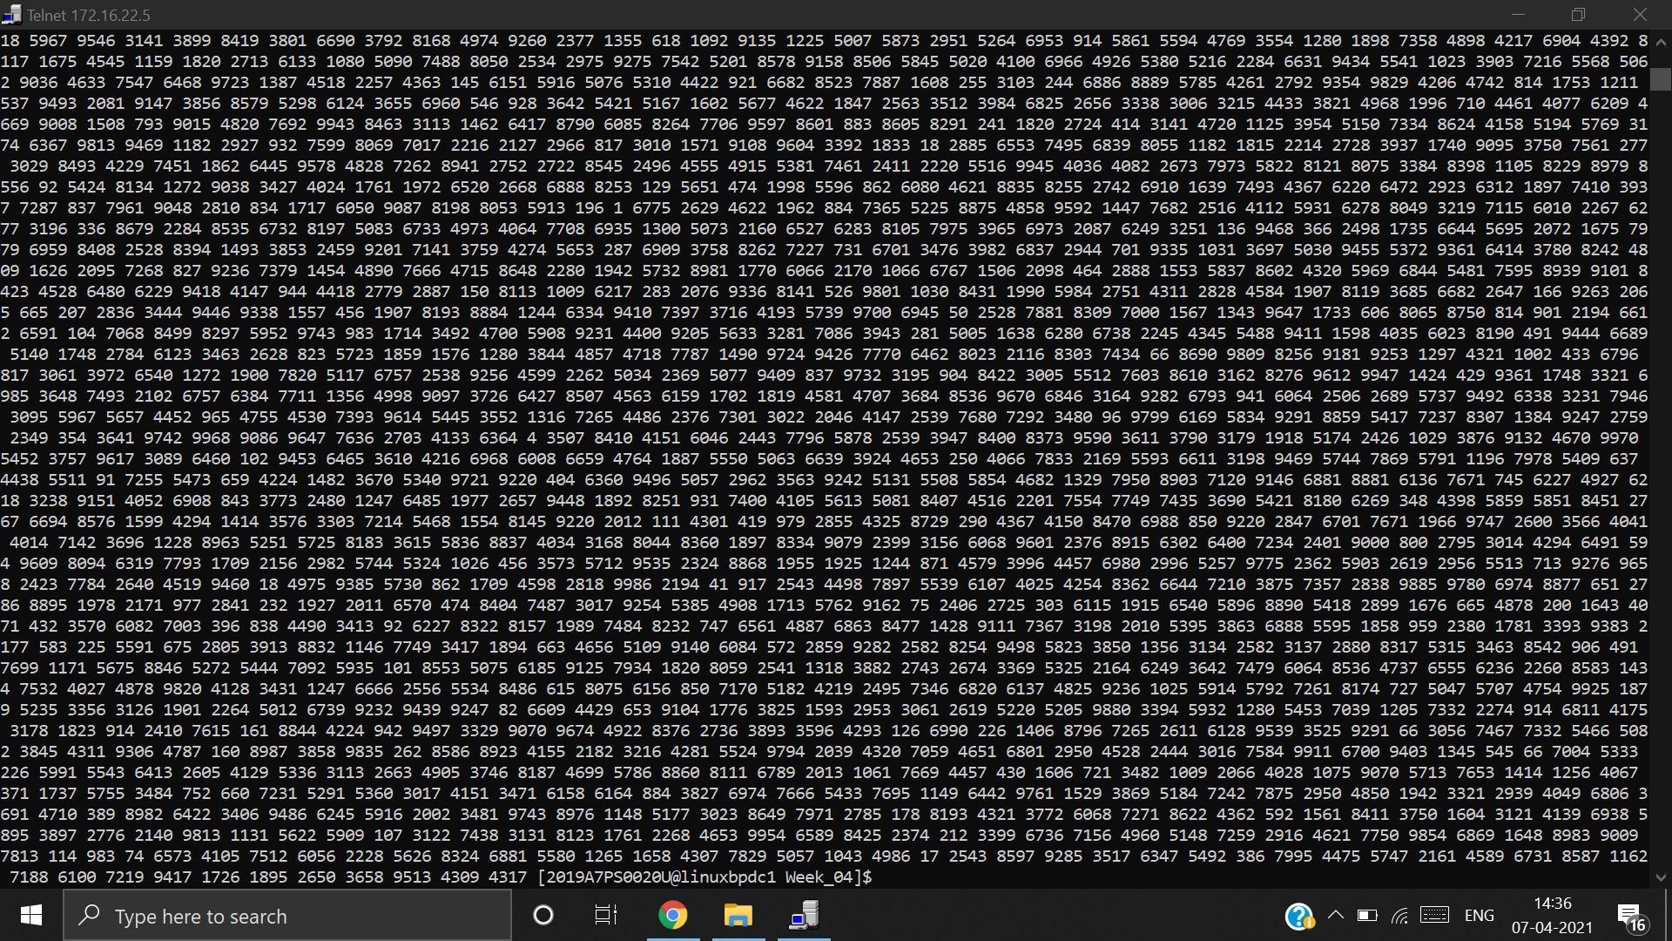

|  |  |
| --- | --- |
| Function | Big O |
|  |  |
| void load(int array[],int size)  {  int index=1;  int length=size;  enQueue(array[1]);  while(size>1)  {  if(2*index > length || 2*index+1> length)  {  break;  }  if(array[2*index]!=-1)  {  enQueue(array[2*index]);  }  if(array[(2*index) + 1]!=-1)  {  enQueue(array[(2*index)+1]);  }  index++;  size--;  }  } | O(1)[declaration, assignment]  O(1)[declaration, assignment]  O(1)  O(n-1)  O[1*(n-1)](arithmetic, comparison, or]  O[1*(n-1)](arithmetic, index, comparison]  O(1)  O[1*(n-1)](arithmetic, index, comparison]  O(1)  O(1)[increment]  O(1)[decrement]  **O(n)** |